

Exploratory Data Analysis Using Tableau

Airbnb NYC 2019

Divya Reddy | Kaggle | 09/03/2019

# Introduction

This is a public dataset obtained from Kaggle - <https://www.kaggle.com/dgomonov/new-york-city-airbnb-open-data> about Airbnb’s in NYC.

The dataset includes some information about the hosts, their availability, location and other metrics like price, number of reviews, type of room, etc. The total no of records in the dataset are 48895.

Link to the Dashboards: <https://public.tableau.com/profile/divya.reddy7203#!/>

# Metadata

|  |  |
| --- | --- |
| **Column Name** | **Explanation** |
| Id | Listing Id |
| Name | Name of the listing |
| Host_Id | Host Id |
| Host_Name | Name of the host |
| Neighbourhood_Group | location |
| Neighbourhood | Area |
| Latitude | latitude coordinates |
| Longitude | Longitude coordinates |
| Room Type | Listing space type |
| Price | In dollars (USD) |
| Minimum_Nights | Minimum number of nights |
| Number_Of_Reviews | Number of reviews received per month |
| Last_Review | Date of last review |
| Availiability_365 | Number of days available when booking |
| Calculated_Host_listings_Count | Amount of listings per host |

# Summary of Data

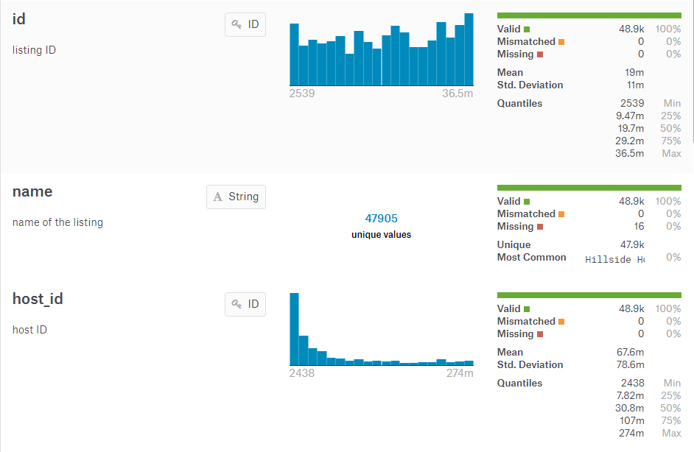

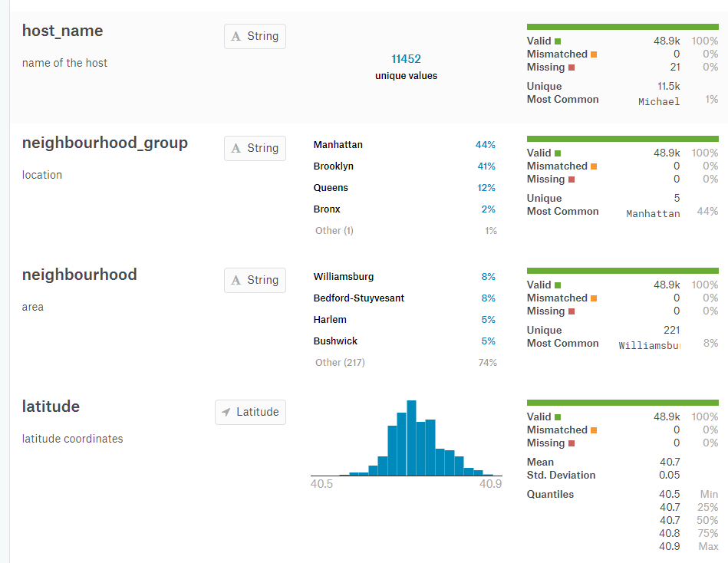

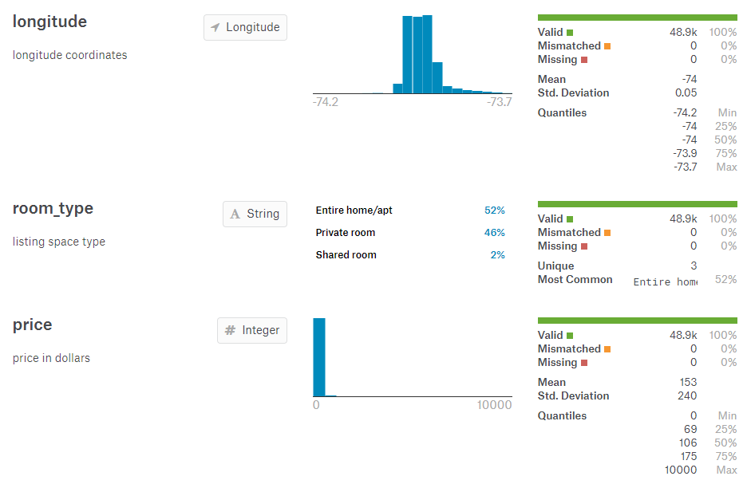

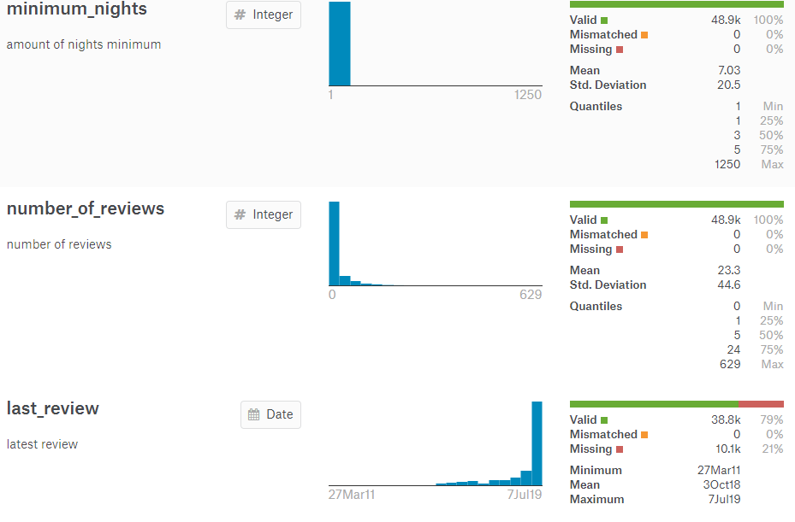

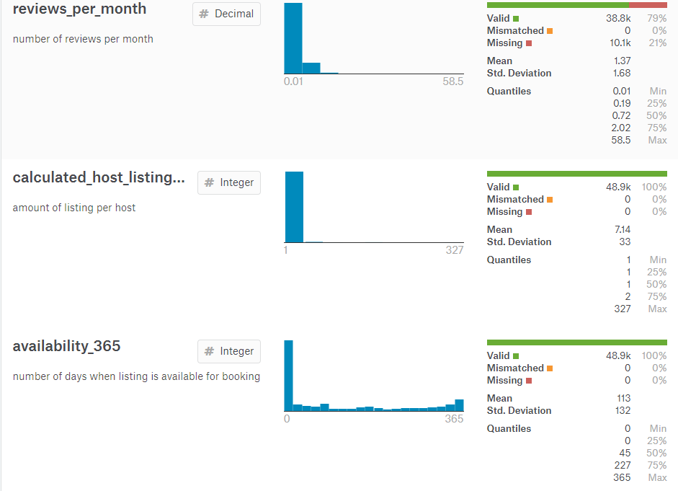

# Sample Data

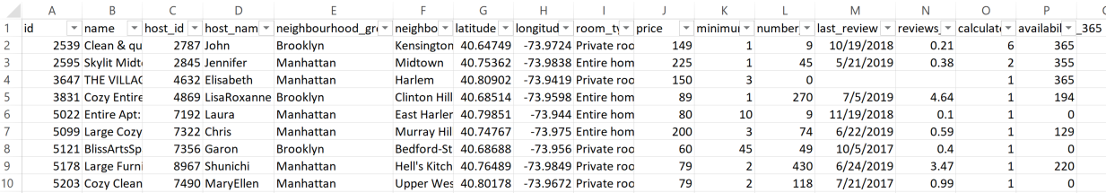

# Tableau Visualizations

The below two visualizations show which neighbourhood groups have the highest listings and their distribution. Manhattan and Brooklyn have the most listings compared to Queens, Bronx and Staten Island

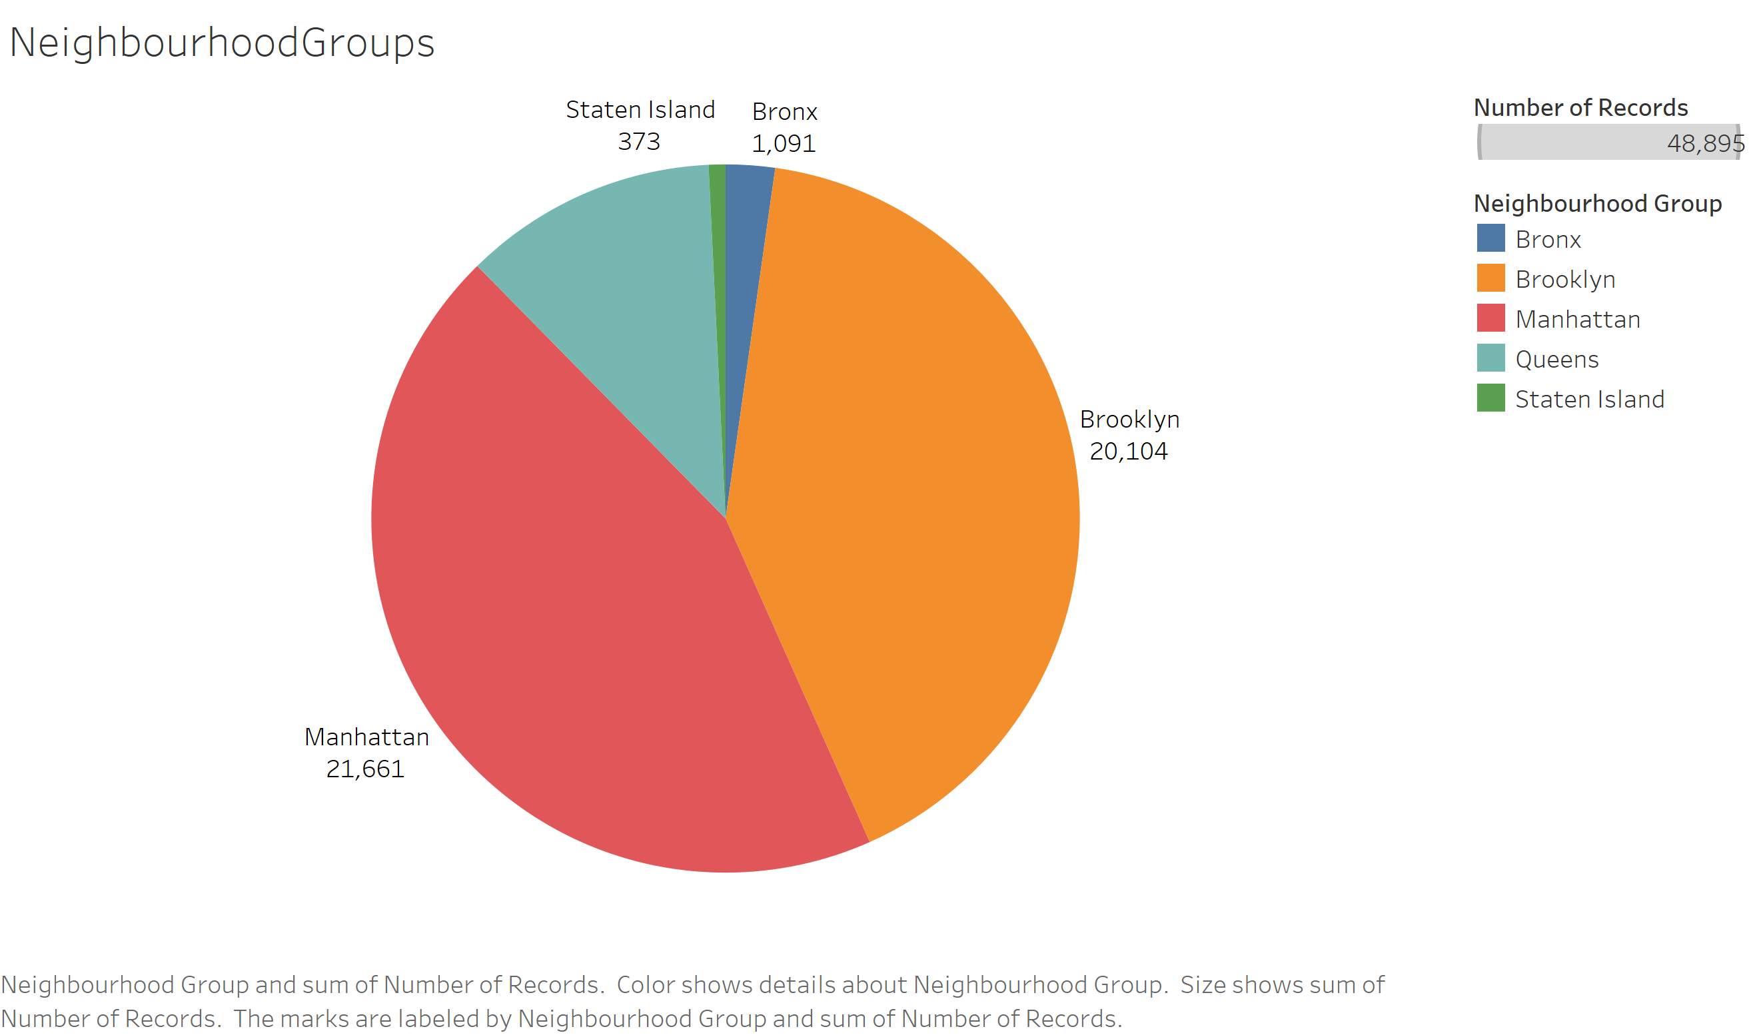

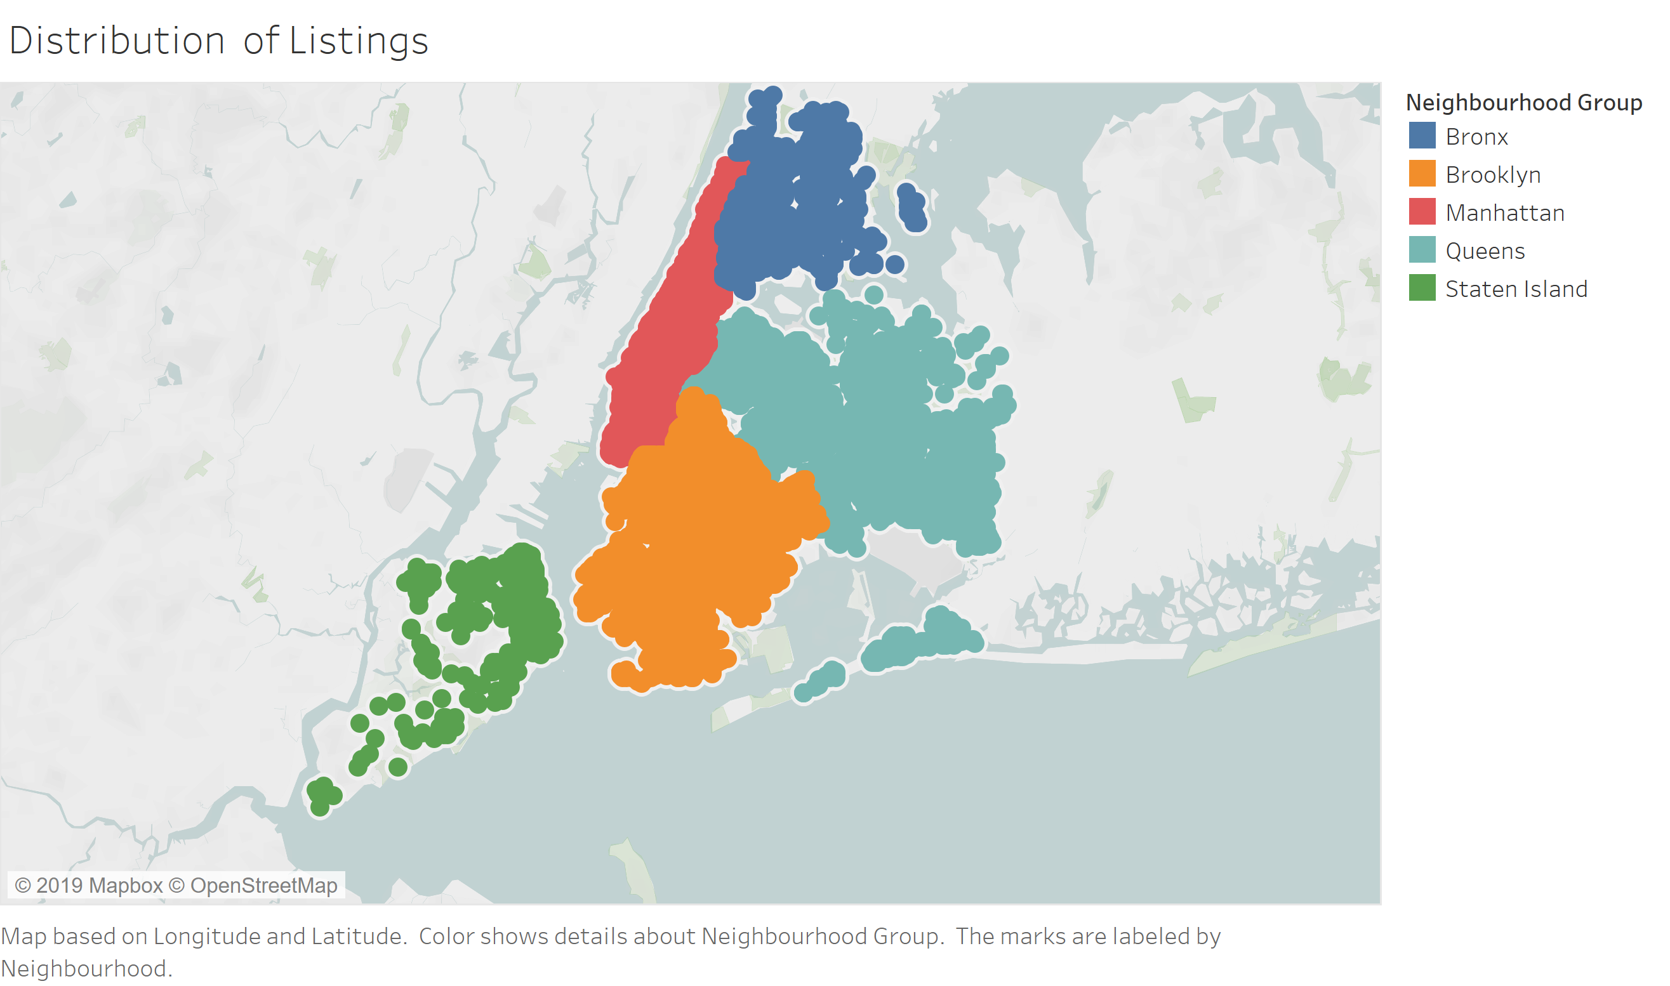

The below vizualization shows neighbourhoods with highest listings

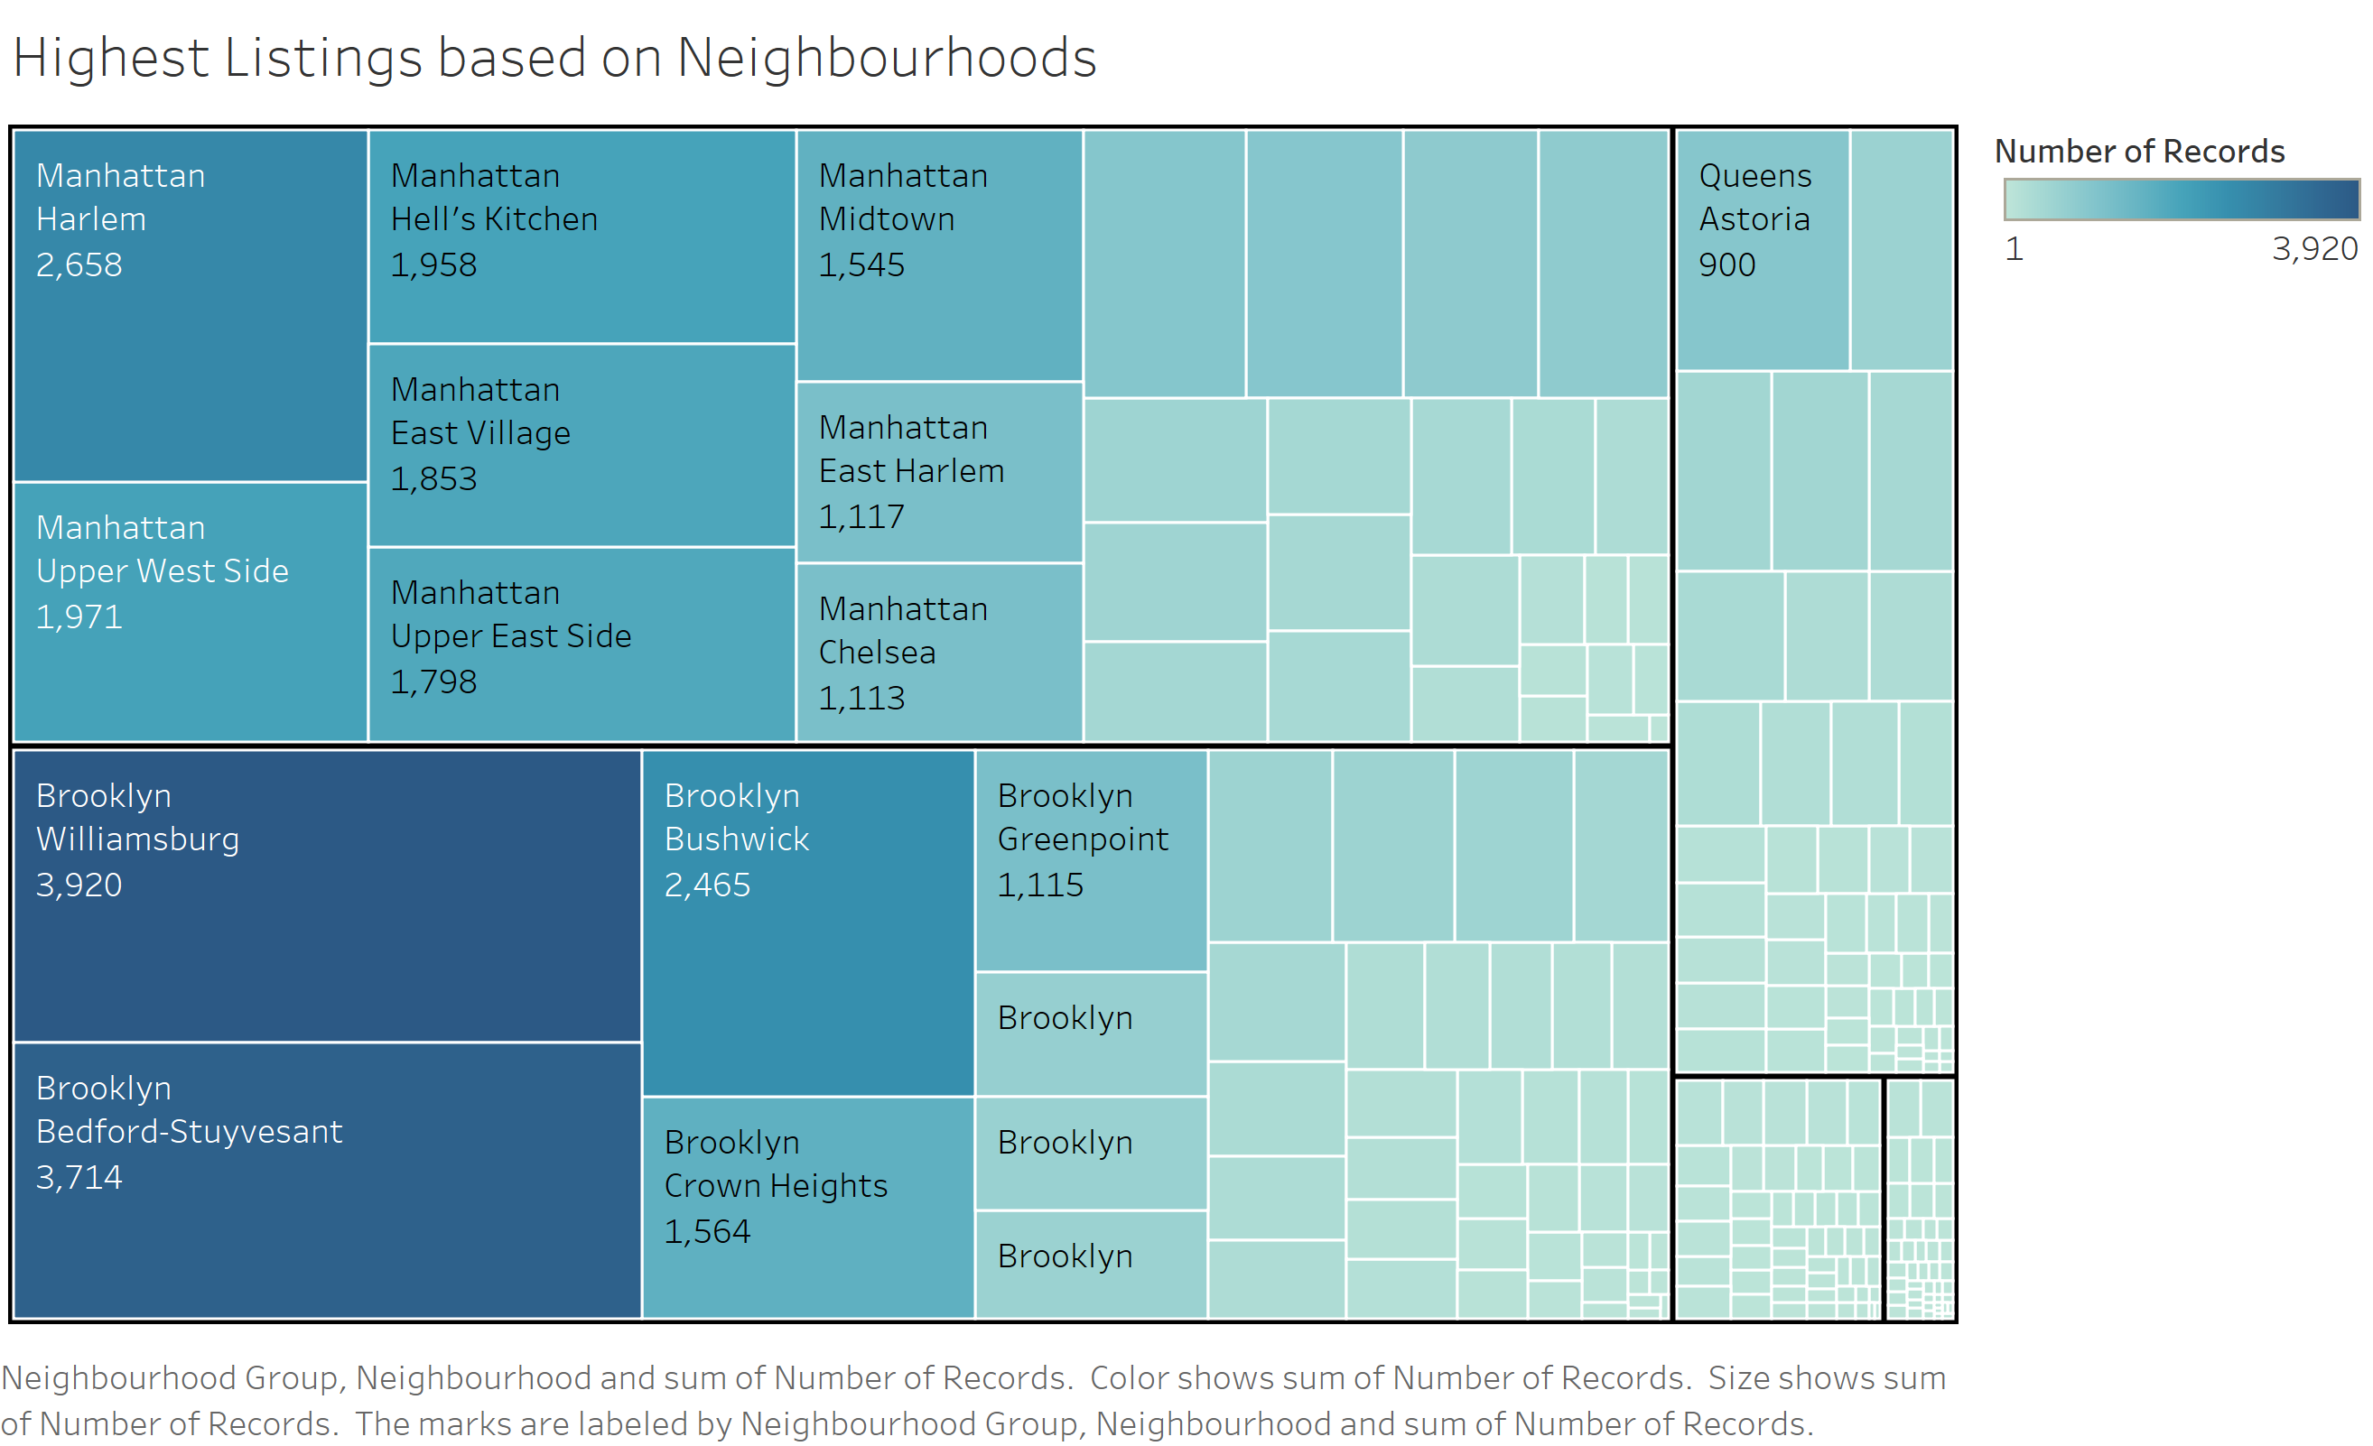

The below figure shows neighbourhoods that have an average price between $300 - $800

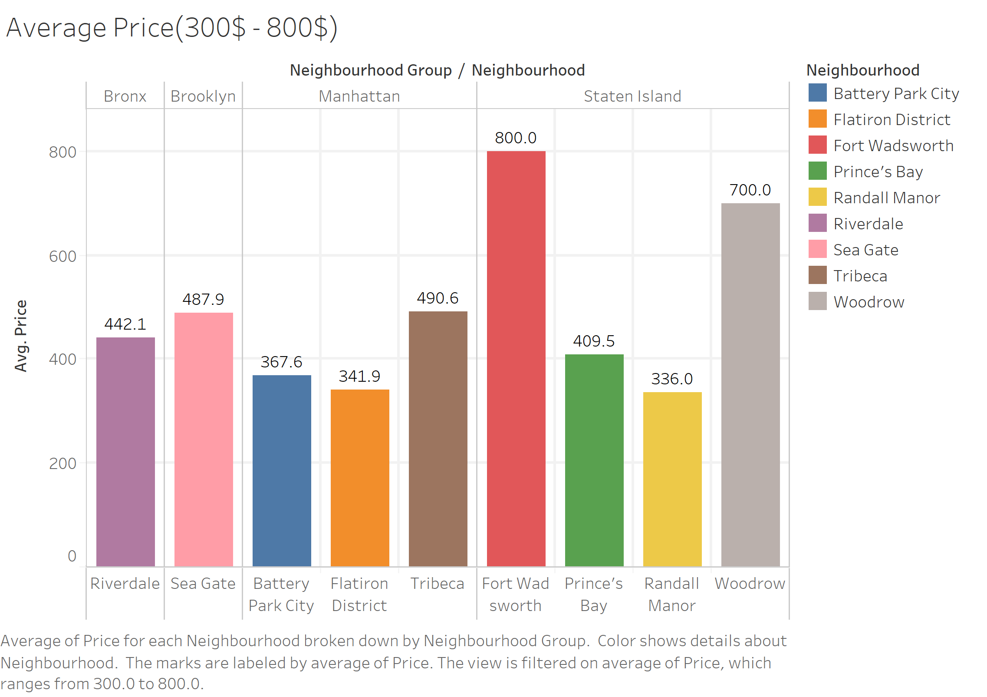

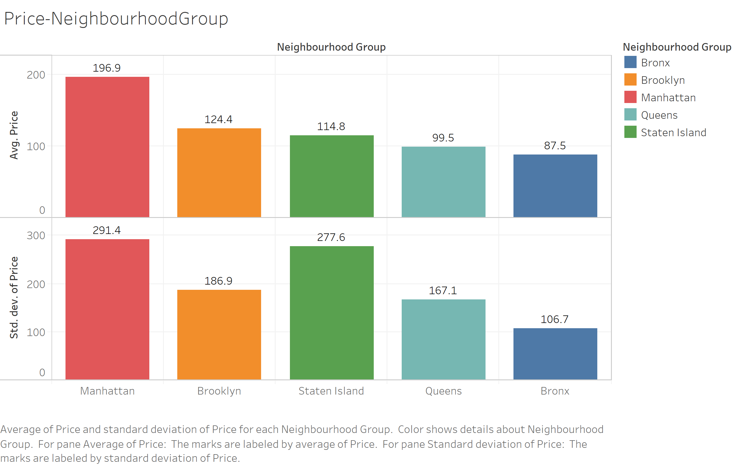

The above graph shows the average price and standard deviation of price in different neighbourhood groups

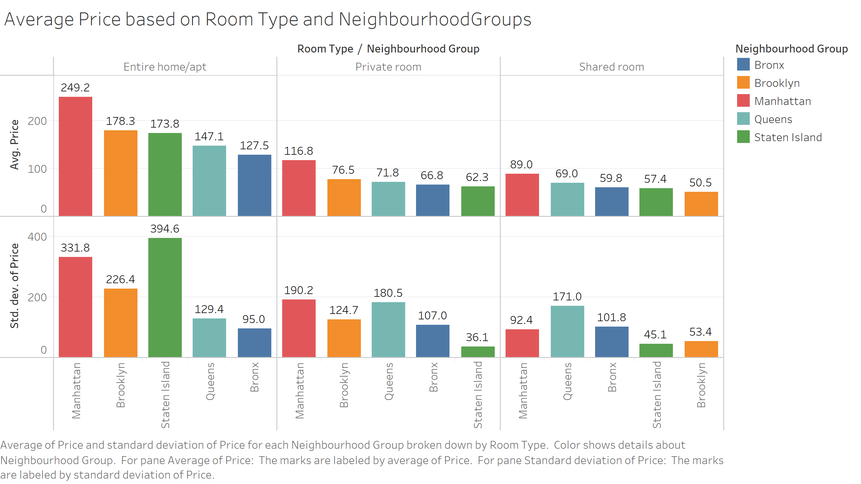

The above graph shows the average price and standard deviation of price segregated by type of listing(room type) and neighbourhood groups.

From the below visualization we can see that most listings have min nights between 1-7 days and 30 days

